**Is Airline Travel Still Safe?**

by **Kesav Adithya Venkidusamy** on July 15, 2022



Crash! Crash! Crash! Travelling in airplane is making your life at risk. Air travel is risky compared to other modes of transportation. Likewise, there has been a lot of chatter in the media regarding the airline crashes and fatalities occurred in recent times. Recent incidents like a Boeing 737-800 plane operating as China Eastern Airline crash occurred on March 21, 2022 killing 123 passengers and 9 crew members and a Boeing operating as SJ182 crashed moments after taking off from Jakarta, Indonesia on January 2021 killing 56 passengers and 6 crew members raised great concern over airline safety among people. With these incidents in consideration, you might get an impression that these days, you are taking your life at stake by travelling in airplane instead of other modes of transportation like automobiles. Is airline still the safest mean of transportation?

**Myth vs Reality**

Though it sounds like airline travel is unsafe, it is in fact still one of the safest modes of transportation. The below chart shows the total number of passenger flight accidents and fatalities by aircrafts for every 100K miles flown over the years. The numbers are not only low for the recent years, but the trend has significantly dropped since 1995.

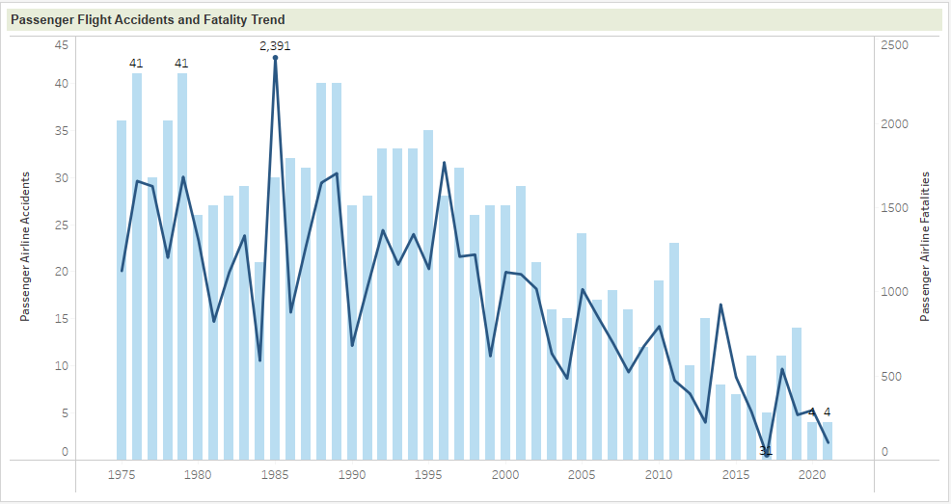

Figure 1: Total number of flight accidents and fatalities since 1975

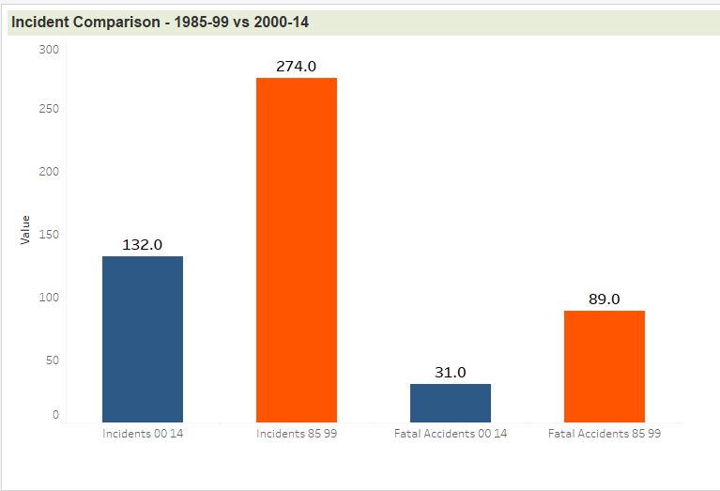There are more statistical data to prove that air travel fatality rate has been decreased substantially. The graph shown in figure 2 shows the number of incidents and fatal accidents over two time periods, the 1985-99 time period and the 2000-14 time period. From the graph, we see the number of accidents has been declined by 57% in 2000-14 period as compared to 1985-99. The fatal accident has also been decreased by 23% in the recent timeframe compared to the previous timeframe where it was 32%. Figure 2: Air Incident between 1985-99 and 2000-14

**Is Automobile travel Safe?**

Next question that pops in everyone’s mind would be how safe is the road travel. Is it better compared to Air travel? At least, you are the one who is in control of the vehicle and can avoid the accident. But the fact is, an average of 35,000 people died every year in auto accidents during last decade on an average of 45,000 accidents reported during the same time period. The below graph shows the total number of fatalities and accidents reported in United States since 1994.

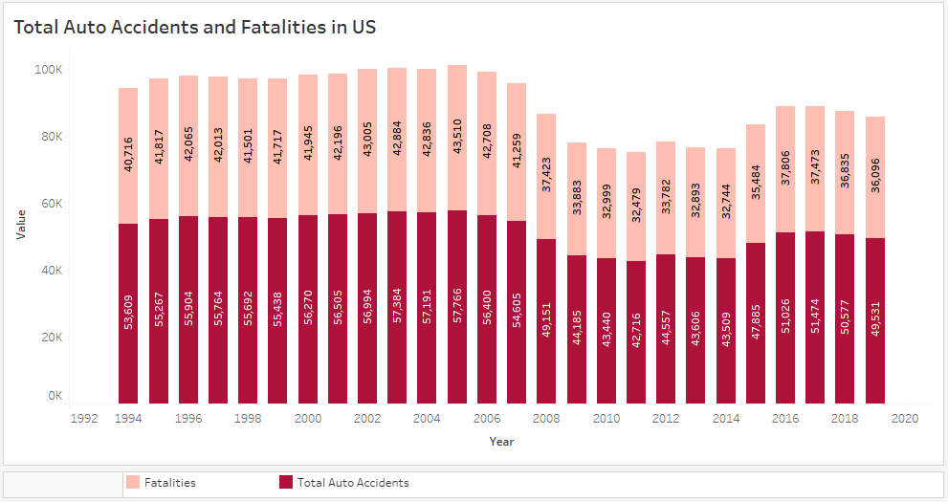

Figure 3: Total number of auto accidents and fatalities in US

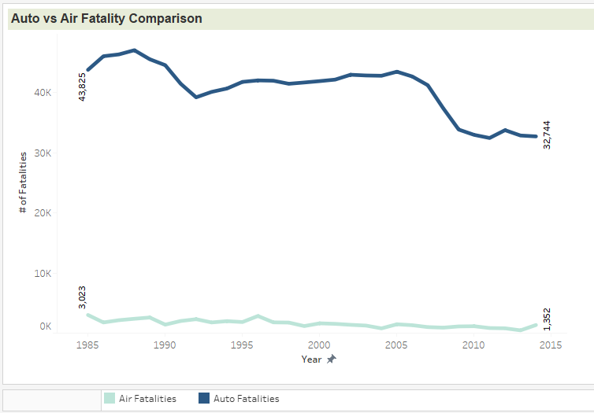 Comparing the charts, airline reported accidents and fatalities around the world were way less compared to total ground accidents and fatalities reported in US alone. The chart shown in figure 4 portrays, per million miles travelled, traveling by road is far more dangerous than traveling by airplane.

Figure 4: Total number of auto accidents and fatalities in US

**Are people afraid to travel by Airline?**

If air travel is considered to be dangerous as media publishes, let us call out the number of passengers that travel by air per year. The area chart shown in figure 5 tells the passenger enplanement since 1975. Looking at the chart below there are billions of people who travel by air on a yearly basis and count increases year over year, except the drop in 2020 due to Covid-19 restrictions. This implies people considering air travel as quickest and safest mode of transportation.

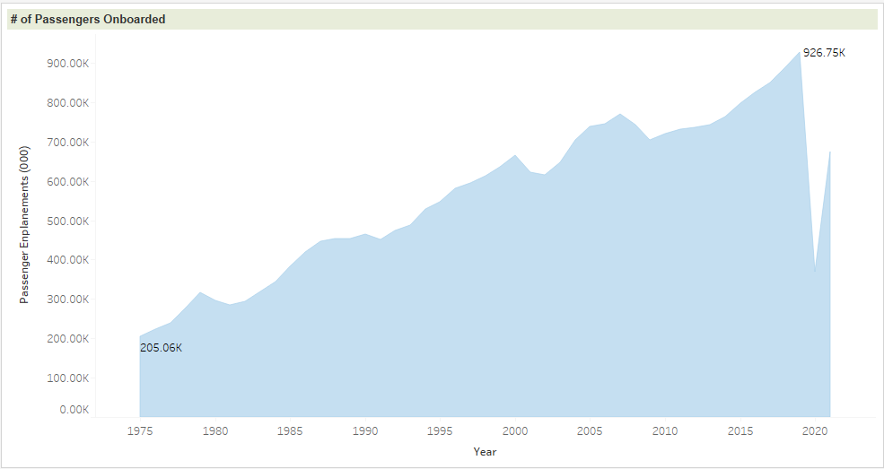

Figure 5: Passenger enplanement since 1975

In conclusion, the media is propagating the false idea that air travel is exceptionally dangerous after a few recent incidents. Based on the analysis, it is clear that air travel is much safer mode of transportation, and while few incidents may have happened recently, that is not only the factor that needs to considered.

References:

Recent Aviation Crashes. Retrieved July 15th, 2022, from <https://www.baumhedlundlaw.com/aviation-accident/recent-aviation-crashes/>

Airline Safety. Retrieved from GitHub <https://github.com/fivethirtyeight/data/tree/master/airline-safety>

Accidents and Fatalities | Retrieved from Google Document | the Aviation Safety Network database (<http://aviation-safety.net>) <https://docs.google.com/spreadsheets/d/1SDp7p1y6m7N5xD5_fpOkYOrJvd68V7iy6etXy2cetb8/edit#gid=1448957446>

Auto accidents and Fatalities | Published by US Department of Transportation | Retrieved July 15th, 2022, from <https://www.nhtsa.gov/data>

Airline Traffic and Capacity by Operating Region | Retrieved July 15th, 2022, from <http://web.mit.edu/airlinedata/www/Traffic&Capacity.html>